

Domestic Violence Instructor Course

April 28th, 29th, 30th, 2025

Las Cruces, NM

Domestic Violence Instructor Couse

Southwest Training Consultants is proud to offer **Domestic Violence Instructor Course.** This class will provide you with the tools necessary to become an instructor in Domestic Violence. Domestic Violence calls in New Mexico are on the rise and if handled improperly, can bring negative press on you and your department. Training regarding this issue is important. This course will train you on what triggers are involved in Domestic Violence, how to handle parties involved and how to successfully prepare for court.

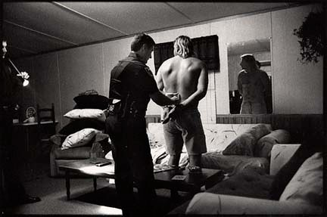

**Hours of Training**

**Course:**

Domestic Violence Instructor Course

**Course Date:**

April 28 -30, 2025

8am – 5pm

**Course Location:**

New Mexico State Police

4055 Sonoma Ranch Blvd

Las Cruces, NM 88011

**Course Cost:**

$600.00 per student