# *Lesson Plan / Instructor Guide*



Use of Force: NM250010

**New Mexico Law Enforcement Academy Annual In-Service Training Curriculum 2025**

**COURSE TITLE:**

**Use of Force**

**INSTRUCTIONAL GOALS:**

New Mexico Peace officers must recognize that they have state and federal authority to use reasonable force to effect an arrest, to prevent escape, to overcome resistance, and protect themselves and others. For their safety, and for the safety and well-being of fellow officers and the public, it is critical that peace officers know the laws governing the use of force.

To present and review information that impacts an officer’s decision-making process as he/she determines appropriate and lawful response to situations involving subject resistance and/or subject assault/battery. This includes a review of United States constitutional law, applicable state law, agency policy, case law, civil law/liability, training, force options, technology and officer experience.

To critically analyze/evaluate actual law enforcement situations (by video and/or incident description) and apply relevant legal standards to determine the appropriateness and reasonableness of the actions of the involved officers.

**INSTRUCTIONAL OBJECTIVES:**

Upon completion of this block of instruction the participant should be able to:

1. Identify and understand selected major United States Supreme Court cases and their direct relevance to use of force applications by law enforcement.

1. Identify and understand New Mexico law that applies to use of force applications by law enforcement.

1. Identify and understand relevant court decisions that deal with mentally ill and/or suicidal subjects surrounding use of force applications by law enforcement.

1. Explain how and why civil liability may be created as a result of use of force applications by law enforcement.

1. Discuss the importance of proper documentation of every use of force application by law enforcement.

1. Describe reasonable force options as response to various situations and circumstances involving resistance, escape and/or flight attempts, assault/battery, and deadly force.

1. Identify and explain relevant factors (tactics, best practices, philosophies, training/experience, and knowledge) which should guide a peace officer in his/her use of force decision(s).

**INSTRUCTIONAL METHODS:**

Lecture supported by audio/visual aids, active class participation/interaction. Use of Force scenario development, instruction and evaluation.

**COURSE DURATION:**

4 hours required – additional practicum hours optional

**CURRICULUM REFERENCES:**

* + New Mexico Criminal and Traffic Law Manual, 2021 Edition
  + Use of Force: New Mexico Law Enforcement Academy Core Curriculum, 2014,
  + National Institute of Justice, Police Use of Force
  + NMAC 29.7.4.4 (C)(D)(G)

**SAFETY CONSIDERATION:**

None in the lecture-based instruction. Proper triple-search and exercise control officer protocol necessary in any scenario-based instruction. Proper triple-search protocols in any virtual firearms training systems.

**EQUIPMENT, PERSONNEL, AND SUPPLIES NEEDED:**

**PowerPoint and projection equipment for lecture.**

**State certified Use of Force instructors**

**TARGET AUDIENCE: NM Certified Peace Officers**

**INSTRUCTOR RATIO: 1 / 60 Lecture**

**EVALUATION STRATEGY:**

**During classroom discussion, the student/cadet should be able to demonstrate through discussion and/or explanation, an understanding of relevant constitutional/case law, state law, policies, tactics, force options, and documentation procedures.**

**December 28, 2023**

**REVISED / REVIEWED BY:**

**NMLEA Staff**

**Course Outline:**

Classroom lecture will include:

* 1. A substantive review of selected United States Supreme Court decisions including: *Graham*

*v. Connor/4th amendment, Tennessee v. Garner and related Circuit appellate cases.*

* 1. A substantive review of selected New Mexico law and New Mexico legal guidelines relevant to lawful detention, arrest and Use of Force options up to and including deadly force.

* 1. Coverage of relevant factors (tactics, best practices, philosophies, training/experience, knowledge) which should guide a peace officer in his/her Use of Force decision(s).

**Course Content:**

Law enforcement duties may require an officer to exert control over people by giving them orders, directing their movement, or taking them into custody. The officer’s goal always is to get subjects to comply *voluntarily*. If they do, the officer will have achieved the objective without making the encounter unnecessarily adversarial and without any risk of injury to officer or subject.

Unfortunately, even the best efforts of the most skilled officer to gain voluntary compliance do not always work. Sometimes you will have to use physical force to achieve control and accomplish your legitimate law enforcement objective. But before you learn *how* to use force options, you must learn *when it is appropriate and lawful to use force*.

**What is the Legality of Police Encounters with Citizens?**

“When reviewing the legality of police interactions with citizens, courts initially assess the nature and extent of the contact. To aid in this analysis, interactions or encounters are divided into three conceptual categories’ as follows: New Mexico Criminal and Traffic Law Manual, 2022 Edition

“First, there are encounters of a consensual nature …otherwise known as a ‘common law right to inquire.’ The basic premise underlying a consensual encounter is that it is voluntary … and is terminable by either party. The objective test in a consensual encounter is whether a reasonable person would think that he or she were free to go.

The following are suggestions for the law enforcement officer to establish a consensual encounter, (i) ask the citizen:

* “May I talk to you?”
* “Can I have a minute of your time?”
* “Do you mind if I search you for drugs?”
* “Would you mind showing me what is in your hand?”
* Or simply walk up to a citizen in a public place and start a conversation.

The next tier of encounters are interactions of a more intrusive nature. These are commonly referred to as detentions, investigatory stops or Terry stops. The justification for these more forceful contacts must be based on facts that are specific and articulable and lead to a rational inference or a reasonable suspicion that criminal activity is undertaken.”

The courts will probably rule that a detention occurs if the officer does one or more of the following:

* Displays a weapon;
* Uses are harsh, accusatorial tone of voice;
* Orders the citizen to do something, e.g., “Stop,” “Open your hands,” “Don’t move,” “Stay right there,” “or “Come over here.”
* Blocks the individuals path with his or her body or a police vehicle;
* Tells the individual that he or she is a suspect;
* Physically touches the individual;
* Retains the individual’s property (driver’s license, or other personal property belonging to the individual)

“The final level of encounter is an arrest. To justify this action, law enforcement officers must possess a higher degree of suspicion, i.e. “probable cause” to believe that a crime has been perpetrated and that a specific person committed it.”

All the above excerpts taken from the New Mexico Criminal and Traffic Law Manual, 2022 Edition

**When Can Officers Use Force as a Lawful Use of Force?**

Law enforcement officers may use force lawfully *when it is needed to achieve control* in five specific situations:

1. To achieve and maintain control of resistive subjects
2. To detain persons reasonably suspected of criminal behavior
3. To make lawful arrests
4. To defend themselves or others
5. To prevent escape (in certain situations where there is imminent danger of serious bodily injury or death)

You cannot use force to punish someone for something he or she has said or done. You cannot use force to retaliate against someone who has offended or angered you. The purpose of a law enforcement officer’s use of force is to ultimately gain or maintain *control of persons and/or situations and/or defend against assault/battery up to and including great bodily harm or death.*

“It is the policy of the New Mexico Department of Public Safety that officers use only the force necessary to effectively bring an incident under control, while protecting the lives of the officer and others and while accomplishing lawful objectives. It must be stressed that the use of force is not left to the unfettered discretion of the involved officers. This is not a subjective determination. The use of force must be **objectively reasonable**.” (NMDPS OPR .01)

______________________________________________________________________________

# The U.S. Constitution – Fundamental Protections

**4th Amendment and Graham v. Connor**

The 4th amendment to the Constitution prohibits “unreasonable search and seizure.” In 1989, the United States Supreme Court found that law enforcement officers’ use of force against subjects was a type of seizure, and therefore, under the Constitution had to be “objectively reasonable.”

The 4th amendment to the United States Constitution specifically addresses:

 **The right of the people to be secure in their persons**, houses, papers and effects, **against unreasonable searches and seizures, shall not be violated**, and no warrants shall issue, but upon probable cause, supported by oath or affirmation and particularly describing the place to be searched and the person or things to be seized.

The case was (Graham v. Connor, 490 U.S. 386, 109 S.Ct. 1865 ) and it is one of two landmark cases addressing law enforcement use of force.

*Graham v. Connor General Overview*:

* 1984 – Dethorne Graham was a diabetic
* Went to the store to get orange juice – too many people so he quickly left to go to another store
* Officer Connor thought Graham’s actions were suspicious and stopped him to further investigate
* Connor was told Graham was a diabetic but he ordered them to wait until he found out what happened at the store
* Graham got out, ran around the car, sat down and passed out briefly f More officers arrived, physical altercation between officers and Graham
* Graham was handcuffed and placed in a patrol unit. Graham sustained a broken foot, cuts on his wrists, bruised forehead, and loud ringing in his right ear.
* Officers were informed Graham had done nothing wrong at the store. He was taken home and released.

x Review and discuss the North Carolina re-enactment video on *Graham v. Connor - http://wn.com/exact/rcw_Maximus*

*In Graham v. Connor*, the Court’s analysis began by considering the subject’s Fourth Amendment right to remain free from any unreasonable seizure against the government’s interest in maintaining order through effective law enforcement.

The Court noted that determining the objective reasonableness for the use of force must be *fact specific*, and established the following four components for determining reasonableness:

The reasonableness of a particular use of force must be:

1. Judged from the perspective of a reasonable officer.

1. Examined through the eyes of an officer on the scene at the time the force was applied, not the 20/20 vision of hindsight.

1. Based on the facts and circumstances confronting the officer without regard to the officer’s underlying intent or motivation.

1. Based on the knowledge that the officer acted properly under the established law at the time.

In the Graham v. Connor decision, the Supreme Court laid out the issues to consider when deciding if a particular use of force is reasonable. These include but are not limited to:

1. The severity of the alleged crime at issue

1. Whether the suspect poses an imminent threat to the safety of officers and/or others

1. Whether the suspect is actively resisting or attempting to evade arrest by flight

_____________________________________________________________________________

**Peace officers will constantly be faced with decisions of when to use force and to what degree it should be applied.**

The Court stated that reasonableness should be judged under the totality of the circumstances from the perspective of a reasonable officer at the scene with similar training and experience. The Court also noted that officers must frequently make split-second decisions.

The totality of the circumstances must be evaluated from *the perspective of the officer at the scene*, rather than from an outsider’s benefit of “20/20" hindsight. Reasonable force must be based on the facts and circumstances known to the peace officer at the time the force was used.

The Supreme Court noted that:

“The amount of force necessary for the situation is determined by objective reasonableness as judged by a reasonable officer given the officer’s training and experience.”

A reasonable officer standard is best determined by asking – would an officer with similar training, experience, and background in a similar set of circumstances, react in a similar manner?

# 4th Amendment and Tennessee v. Garner

In 1985, based on a person’s Fourth Amendment protection from unreasonable seizures by peace officers, the United States Supreme Court ruled on a case [*Garner*] where an officer used a firearm (deadly force) to prevent the escape of a non-violent fleeing felon.

The officer in this case relied on the “fleeing felon” standard, which allowed the use of deadly force on any category of felon that was attempting to escape. The Court applied the reasonableness test set forth in the Fourth Amendment.

The ultimate question is whether the use of the particular force in a particular situation was reasonable. To make that determination, the court must balance the nature and quality of the intrusion on the individual’s Fourth Amendment interests against the importance of the governmental interests alleged to justify the intrusion.

*Tennessee v. Garner General Overview:*

* Memphis Tennessee officers responded to a possible burglary in progress.
* Officer went to the back of the house and saw a suspect (Garner) run across the yard and attempt to scale a fence.
* Officer ordered him to stop and said he was reasonably sure he was unarmed but would escape if he made it over the fence.
* Officer shot and killed Garner.

At the time, officer acted according to Tennessee state statute and Memphis Police Dept. policy which authorized all necessary means to effect the arrest of a fleeing or forcibly resisting subject.

Upon review, the USSC determined that apprehension by use of deadly force is a seizure subject to the reasonableness standard of the 4th amendment thereby addressing the legal issue as whether or not the totality of the circumstances justified the seizure.

The USSC further determined, “*The use of deadly force to prevent the escape of all felony suspects, whatever the circumstances, is constitutionally unreasonable. It is not better that all felony suspects die than that they escape. Where the suspect poses no immediate threat to the officer and no threat to others, the harm resulting from failing to apprehend him does not justify the use of deadly force to do so. It is no doubt unfortunate when a suspect who is in sight escapes, but the fact that the police arrive a little late or are a little slower afoot does not always justify killing the suspect. A police officer may not seize an unarmed, non-dangerous suspect by shooting him dead*.”

The USSC suggested that there are three circumstances when an officer can lawfully use deadly force:

1. when the officer is threatened with a deadly weapon.
2. when the officer has probable cause to believe that the suspect poses a threat of serious physical harm or death to the officer or to another person.
3. To prevent escape when the officer has probable cause to believe that the suspect has committed a crime involving threatened or actual serious physical harm or death to another person.

x The Court also noted that, when feasible, a warning should precede the use of deadly force.

**5th and 14th Amendments – Due Process Protections**

NOTE: Both amendments are textually identical. The 5th amendment applies to the federal government while the 14th applies to the states.

* “No person shall be held to answer for a capital, or otherwise infamous crime, unless on a presentment or indictment of a Grand Jury, except in cases arising in the land or naval forces, or in the Militia, when in actual service in time of war or public danger; nor shall any person be subject for the same offense to be twice put in jeopardy of life or limb; nor shall he be compelled in any criminal case to be a witness against himself, **nor be deprived of life, liberty, or property without due process of law;** nor shall private property be taken for public use without just compensation.”

**8th Amendment – Protection from Cruel and Unusual Punishment**

* Excessive bail shall not be required, nor excessive fines imposed, **nor cruel and unusual punishments inflicted.**

______________________________________________________________________________

# Subject’s Resistance

A subjects’ level of resistance/actions to a lawful detention or arrest will determine the type of force used by peace officers.

The following examples illustrates how a subject’s resistance/actions *may* correlate to the force applied by an officer. *Important note - Officers must take into account the *totality of the circumstances* when selecting a reasonable force option. Additionally, officers must be aware of and comply with their specific agency policies regarding appropriate force options. It is not the intent of these examples to imply that an officer’s force options are limited based on any single factor.

|  |  |  |  |  |
| --- | --- | --- | --- | --- |
| **Subject’s Actions** **Description** | | | | **Possible Force Option** |
| Cooperative Subject offers no | | | | Professional command appearance |
| resistance | | | | Non-verbal actions |
|  | | | | Requests and/or commands |
| Passive Non-Compliance Does not respond to | | | | Officer’s strength to take physical control, |
| verbal commands but | | | | including lifting/carrying. |
| also offers no physical | | | | Control holds and techniques to direct |
| form of resistance | | | | movement and/or immobilize a subject. |
| Active Resistance Physically evasive | | | | Control holds and techniques to control the |
| movements to defeat | | | | subject and situation. |
| an officer’s attempt to | | | | Use of personal weapons in self-defense |
| control – including | | | | and to gain advantage over the subject. |
|  |  |  | bracing, tensing, | Use of devices to secure compliance and | |
|  |  |  | running away, or | and ultimately gain control of the situation. | |
|  |  |  | verbally signaling an |  | |
|  |  |  | intention to avoid or |  | |
|  |  |  | prevent being taken |  | |
|  |  |  | into or retained in |  | |
|  |  |  | custody. |  | |
| Assaultive |  |  | Aggressive or | Use of devices and/or techniques to secure | |
|  |  |  | combative; | compliance and ultimately gain control of | |
|  |  |  | attempting or | the situation. | |
|  |  |  | threatening to assault | Use of personal body weapons in self | |
|  |  |  | the officer or another | defense and to gain advantage over the | |
|  |  |  | person. | subject. | |
| Life Threatening | |  | Any action likely to | Utilizing firearms or any other available | |
|  | |  | result in serious | weapon or action in defense of self and | |
|  | |  | bodily injury and/or | others. | |
|  | |  | the death of the officer |  | |
|  | |  | of others. |  | |

*Peace officers must use the force option appropriate and/or as is objectively reasonable for the situation as conditions may change rapidly. Officers must continually reevaluate the subject’s action(s) and must be prepared to transition as needed to the appropriate force options.

______________________________________________________________________________

The following situations are presented as a few examples of reasonable and unreasonable use(s) of force based on the level of resistance/actions that is being offered by a subject during a lawful traffic stop:

**Situation**: During a traffic stop, an officer discovered that the driver had several outstanding traffic warrants.

**Subject’s Actions**: The driver offered no resistance, was cooperative, and responded immediately to the officer’s verbal direction/commands.

**Officer’s Response**:

*[Reasonable]* – The officer’s presence and verbal direction/commands controlled the situation.

*[Unreasonable]* – The officer used a physical control hold immediately before giving verbal commands. The driver became fearful of the officer’s actions and began to struggle with the officer. Absent other mitigating factors, the officer’s use of force was unreasonable and may have escalated the threat.

______________________________________

**Situation**: During a traffic stop, an officer discovered that the driver had several outstanding traffic warrants.

**Subject’s Actions**: The driver complied with the officer’s verbal command to get out of the car and showed no signs of threatening behavior but refused to cooperate in any other way.

**Officer’s Response**:

*[Reasonable]* – The officer used a firm grip to overcome the driver’s passive resistance to the officer’s efforts to direct the movement of the driver and maintain control of the situation.

*[Unreasonable*] – The officer used an impact weapon to disable the subject before applying a control hold and placing the subject under arrest.

________________________________________

**Situation**: During a traffic stop, an officer discovered that the driver had several outstanding traffic warrants.

**Subject’s Actions:** The driver complied with the officer’s command to get out of the vehicle but then pulled away, made two fists, and assumed a fighting stance.

**Officer’s Response:**

[Reasonable] -

*[Unreasonable]* – The officer continued making verbal requests for the subject to comply and attempted no other action to gain control of the subject. Even though the subject was not actively attacking the officer, he was actively and aggressively resisting the officer’s attempt to arrest him. By not responding to the changing situation with reasonable force, the officer may have placed him/herself in greater danger of losing control and placed him/herself at the risk of serious injury.

_________________________________________________________________

# Force Options

Peace officers must recognize that they have a range of force options available to them. However, in all cases, the use of force must be reasonable compared to the threat, resistance, and other circumstances known to the officer at the time the force was used.

**Force options** are choices available to a peace officer in each agency’s policy to overcome resistance, effect arrest, prevent escape, or gain control of the situation.

The objective for the use of force by peace officers is to gain and maintain control of an individual and the situation.

Force options include show of force and use of force:

*Definition of Show of Force: Demonstrating the ability to use force but not putting it into action. There is no tissue damage, and the action can be recalled. For example:*

* Loading a baton w/verbal commands but not striking the subject
* Unholstering a Taser, OC, or firearm, pointing it at the subject, followed by verbal commands but not actually firing.

*Definition of Use of Force: Any action that has the potential for tissue damage than cannot be recalled. For example:*

* Striking a subject in the leg with a batonf Spraying a subject in the face with OCf Firing a Taser and striking the subject with the prongs f Firing a semiautomatic pistol and hitting the subject

Peace officers are required to:

1. use the type of force which is objectively reasonable under the circumstances.

1. use only the amount of force which is objectively reasonable to overcome resistance and to gain or maintain control of a subject and/or situation.

1. conform to agency policy and federal and state law.

Importantly, the amount of force applied shall not exceed what is reasonable to overcome the subject’s resistance to gain or maintain control of the subject and/or situation. Each officer must rely on their judgment to employ **objectively reasonable** force for that specific situation.

There are a number of factors that can affect which force option is selected. The following identifies but is not limited to some of the more critical factors and considerations:

Public Safety

* What action is required for self-defense or defense of others?

What is the amount and nature of the resistance which must be overcome?

* Passive resistance?
* Active resistance?
* Assaultive resistance?
* Life-threatening resistance?

Is there a presence of a weapon and what type of weapon?

* Firearms?
* Cutting/stabbing/hacking weapons?
* Blunt trauma/Impact weapons?

What is the seriousness and nature of the offense?

* Investigatory detention?
* Misdemeanor cite and release?
* Misdemeanor arrest?
* Non-violent felony?
* Violent felony?

What are the characteristics of the subject as compared to the characteristics of the officer?

* Size?
* Age?
* Capabilities (if known)
* History

What is the availability of assistance?

* Number of officers at the scene?
* Availability of backing officers?

What is the nature and condition of the location and surroundings?

* Is there danger to bystanders?
* What is the availability of weapons?

**Force Options may include:**

* Mere professional appearance

* Verbal requests and commands

* Officer’s strength to take physical control, including lifting and carrying.

* Empty-Hand Control holds and techniques to direct movement, immobilize a subject, control the subject and/or situation.

* Use of personal body weapons in self-defense and to gain advantage over the subject.

* Use of devices (baton, Taser, OC, etc.) to secure compliance and ultimately gain control of a situation.

* Utilizing firearms or any other available weapon or action in defense of self or others.

**Use of Vascular Neck Restraint Techniques as a Force Option:**

* ***A law enforcement officer shall not*:** Use a vascular neck restraint unless a person's attack poses a threat of imminent harm to the officer or another person; provided that an officer shall cease the use of a vascular neck restraint as soon as the person no longer poses a threat of imminent harm to the officer or another person. (29-7D-3) Article 7D Use of Force Procedures

* The use of vascular neck restraints as a force option should only be considered in a deadly force situation.

* Vascular neck restraints have a high probability for great bodily injury or death and should not be categorized or viewed as a pain compliance technique such as escort holds or wrist locks.

_______________________________________________________________

# Use of Force Option Related Case Law

***Impact Munitions Case Law***

(Review and discuss with the class as per the handouts)

* *Deorle v. Rutherford*, 272 F .3d 1272 (9th Circuit, 2001)
* *Mercade v. City of Orlando*, 407 F .3d 1152 (11th Circuit, 2005)
* *Phillips v. Community Insurance Corporation*, No 10-1654 (7th Circuit, 2012)

***Taser Case Law***

(Review and discuss as per the handouts)

* *Casey v. City of Federal Heights*, #06-1426, 509 F .3d 1278 (10th Circuit, 2007)
* *Hennix v. Prickett et al.,* #12-1307 (10th Circuit, 2007)
* *Beaver v. City of Federal Way* 2007 Taser U.S. Dist. LEXIS 64665 (Dist. Washington)

* + The use of Taser involves the application of force.
  + Each application of a Taser involves an additional use of force. o Multiple applications of a Taser cannot be justified solely on the grounds that a suspect fails to comply with a command, absent other indications that the suspect is about to flee or poses an immediate threat to an officer. This is particularly true when more than one officer is present to assist in controlling the situation.
  + Any decision to apply multiple applications of a Taser must take into consideration whether or not a suspect is capable of complying with an officer’s commands.

***Suicide/Mentally Ill Case Law***

(Review and discuss as per the handouts)

* *Allen v. Muskogee, Oklahoma*, 119 F .3d 837 (10th Circuit, 1997)  *Hasting v. Barnes*, No. 04-5144 (10th Circuit, 2007)

______________________________________________________________________________

# HANDCUFFING AS A USE OF FORCE

Does an officer have to have a reason to handcuff an individual? Simply saying “officer safety” is not enough. An officer must justify the use of handcuffs every time they are used. The officer must be able to explain why you felt there was a threat and why the use of handcuffs would eliminate that threat.

US v. Albert, (2009): “A Terry stop does not become unreasonable just because police officers use handcuffs on a subject.” Neff, 300 F.3d at 1220. However, the use of handcuffs is greater than a de minimus intrusion and thus “requires the government to demonstrate that the facts available to the officer would warrant a man of reasonable caution in the belief that the action taken was appropriate.:” Melendez-Garcia, 28 F.3d at 1052.

Considerations:

x Threat of harm to the officer, public and/or subject. x What gives the officer reason to believe there is a threat of harm? x If the officer cannot justify the use of handcuffs, don’t use them.

x Consider disparity of force (positive v. negative) i.e., large male officer v. petite female x Is there an attempt at flight? x What is the level of resistance?

x What can you explain to a jury in plain English that would justify the use of handcuffs? Especially if there is no crime.

How long can handcuffs be left on? Officers must be reasonable in the amount of time they leave handcuffs on if not arrest has been made. Once it has been determined that no crime has been committed and it is safe to do so, officers must remove the handcuffs.

Handcuffing as an excessive use of force:

x Turek v. Saluga, 2002) AELA Monthly Law journal 2008 (10) – Federal court of appeals found that a deputy sheriff handcuffed an arrestee too tightly and refused to loosen the handcuffs. Also, after learning of pre-existing injuries, and the arrestee posed no threat to the officer and was not resisting, the deputy still refused to loosen the handcuffs. A neurologist found a new injury to the arrestee’s ulnar nerve resulting in the loss of function of the right hand.

x Use of force after handcuffing AELE Monthly Law Journal 2008 (11) and AELE Monthly Law Journal 2012 (9) – When the subject is handcuffed and the threat of harm has been stopped, the use of force also stops. Exception: When the threat continues. If, after the subject is handcuffed and in custody but continues to be a threat with personal weapons other than hands, the officer is justified to use a reasonable amount of force to stop the threat. The officer will need to be able to explain his/her actions/use of force in response to the continued threat.

____________________________________________________________________________

# Sudden and Unexpected Death Proximal to Restraint

*Definition: Any unexpected and unintentional death that occurs while a subject in in police custody. Such deaths usually take place after the subject has demonstrated bizarre and/or violent behavior and has been restrained.*

 Does not include all “in-custody deaths” or deaths that are a result of shootings or suicides or accidental falls.

## Research

There have been many studies into the causes of unexpected deaths while in police custody, but none have defined a clear cause. There are many commonalities:

* People suffering from Excited Delirium Syndrome (ExDS)  Other psychological disorders  Drug induced delirium.
* Anti-psychotic medication or a patient off of medication
* Some altered level of consciousness

Research has also shown that it is not a cause-and-effect relationship as to the type of force used in relationship to the death of the individual.

“Police weapon use does not appear to be a predictive factor for in-custody deaths, but personal behavior including chronic drug and alcohol abuse, appears very important as a predictive factor. Personal physiological characteristics may also play a part in predicting the risk factor for sudden in-custody death. These factors often remain invisible to law enforcement personnel and only present during medical intervention or at an autopsy. Some of these factors include, but are not limited to:

* Dehydration
* Low blood sugar
* Epilepsy
* Current or prior head injury
* Underlying psychiatric disease-paranoid schizophrenia
* Enlarged heart
* Small vessel wall thickening
* Coronary atherosclerosis” (Flosi, 2011)

Officers cannot be expected to diagnose a person’s medical condition when faced with rapidly evolving circumstances out on the street but we can recognize symptoms and have a plan to increase the chances of that person surviving the distress they are experiencing.

Common Symptoms:

* All of the above noted conditions listed directly above share similar symptoms with Excited Delirium Syndrome (ExDS)

* Although ExDS doesn’t have an accepted medical diagnosis, it often manifests itself with:

* + Bizarre, violent and agitated behavior o Altered mental states and delirium.
  + Incoherent speech o Hyperactivity
  + Extreme endurance and unusual strength o Autonomic dysregulation including diaphoresis (sweating) o Hyperthermia o Extreme paranoia o The desire to remove clothing (possible from increased body heat) o Breathing heavily
* Effects of these symptoms:

* + Not listening to or obeying commands o Hallucinations o Appears confused.
  + Paranoid behavior/misplaced fear of police o Doesn’t feel pain. o Increased strength o Struggling even while in custody/doesn’t get tired.
  + Various levels of force seem to have no effect (OC, baton, etc.)

The most likely way to mitigate or prevent sudden in-custody deaths proximal to restraint is to focus on the individual and the symptoms that are present, specifically if ExDS is suspected. A proper assessment can be done by first trying to verbally calm the subject.

If the officer suspects ExDS:

* Have a medic unit on standby (defer custody attempts until a medic unit is on site if possible)
* Control the subject as quickly and safely as possible.
* Minimize struggle during restraint.
* Get medical attention as soon as possible.

If a medical unit has not arrived and you have the subject in custody, focus on:

* Calming techniques
* Cooling techniques
* Transport to hospital as soon as possible

____________________________________________________________________________

# CONFRONTATIONAL DYNAMICS

Key Considerations:

* OVERT ACTION IS AN ACT THAT MOVES SUBJECT FROM A THREAT TO ATTACKING
* OVERT ACTION - SHOWS INTENT TO ATTACK
* OVERT ACTION - CREATES OR CAUSES OPPORTUNITY TO COMPLETE AN ATTACK! IAMO [Subject has the ……]
* I – Intent
* A – Ability (Able bodied)  M – Means (Actual tool) x O- Opportunity

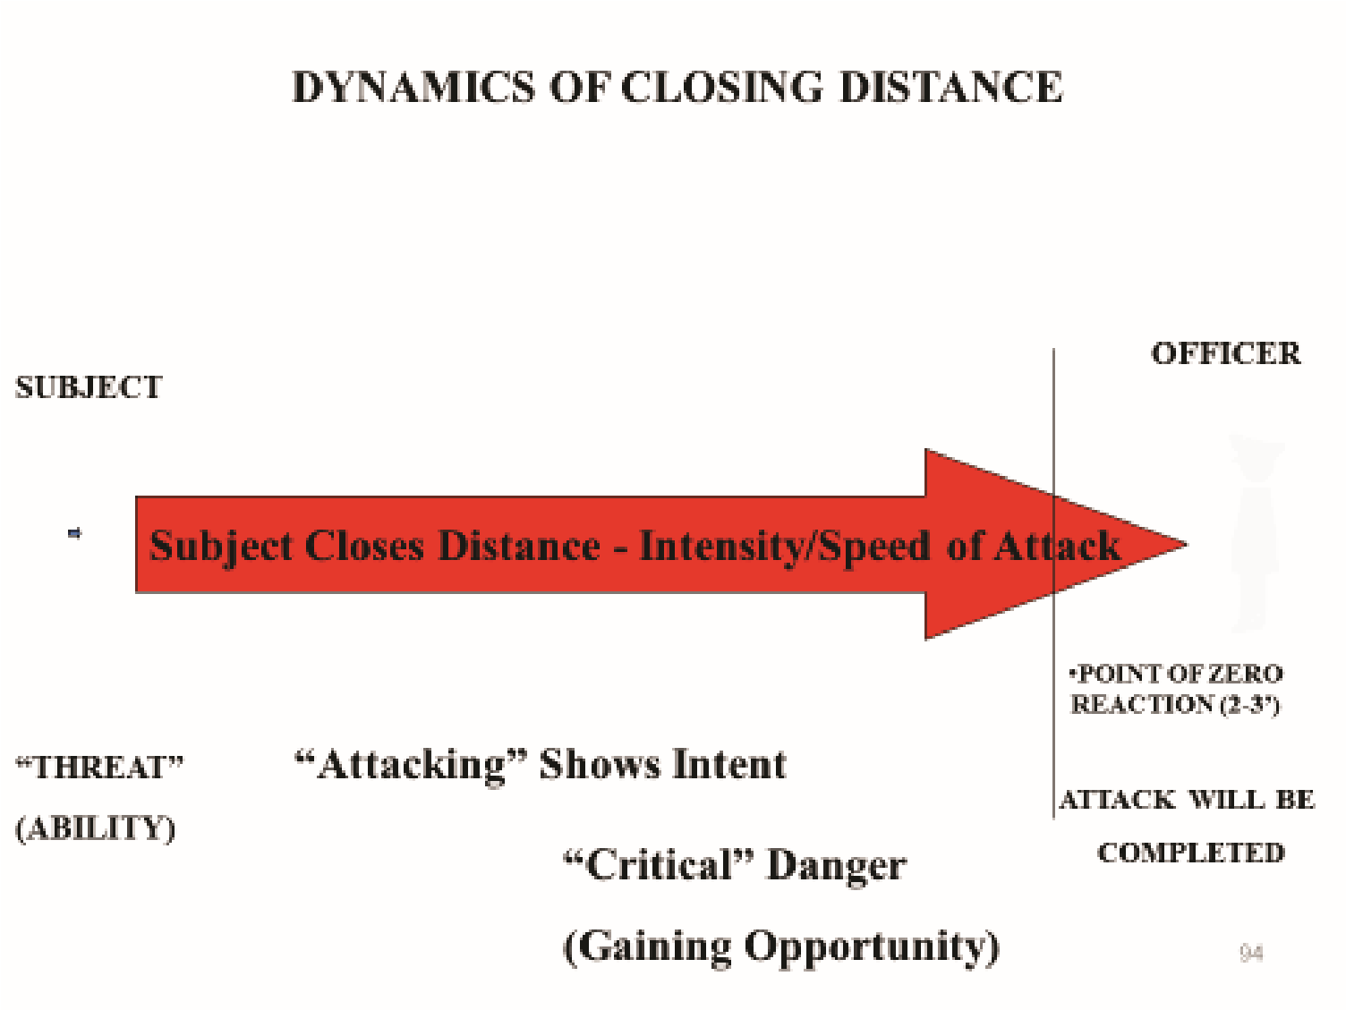

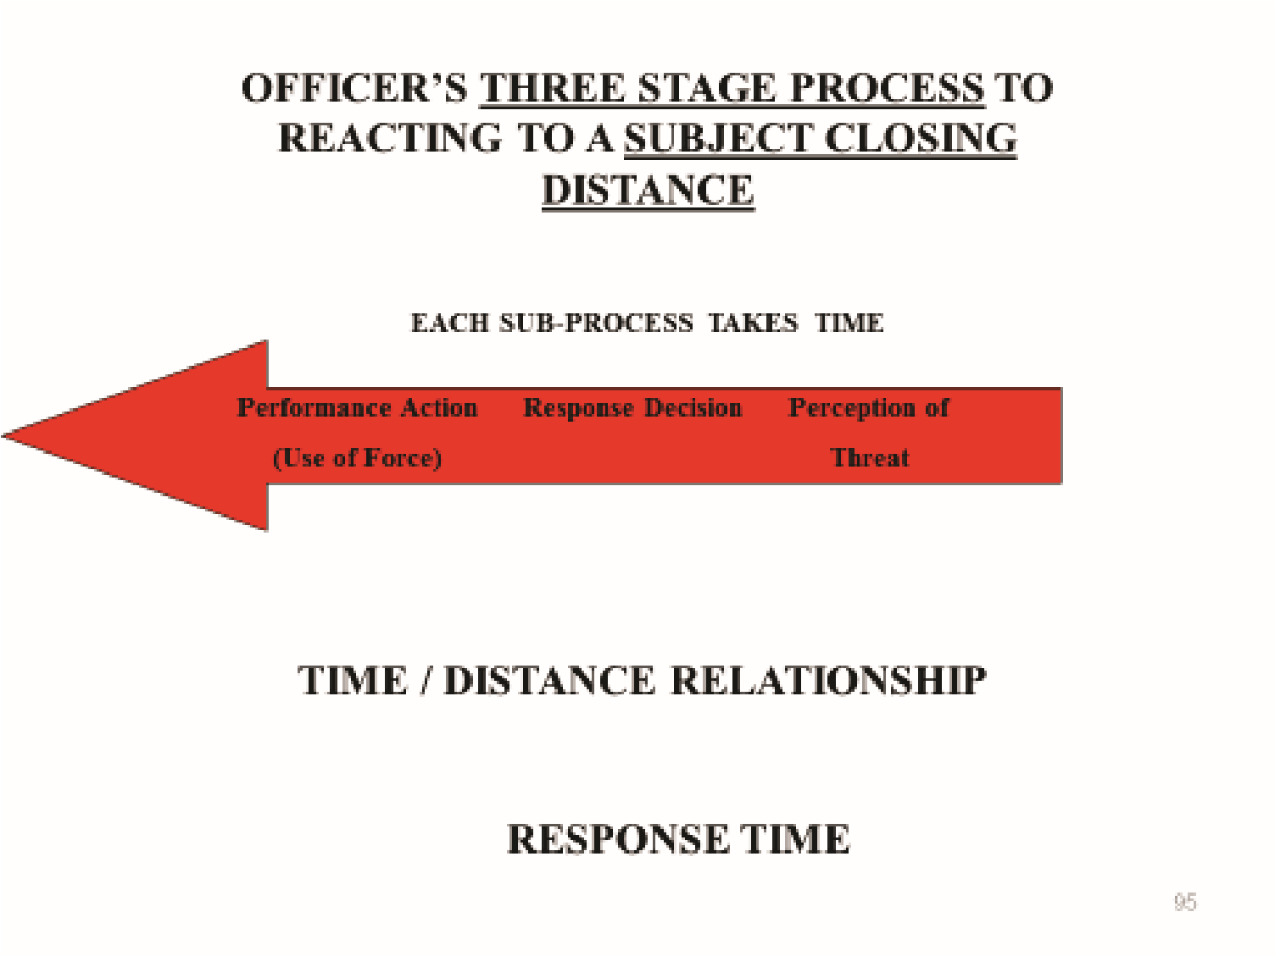

________________________________________________________________

# Deadly Force

*Definition of Deadly Force: Any action by the manner in which it is used, is likely to cause serious bodily injury or death.*

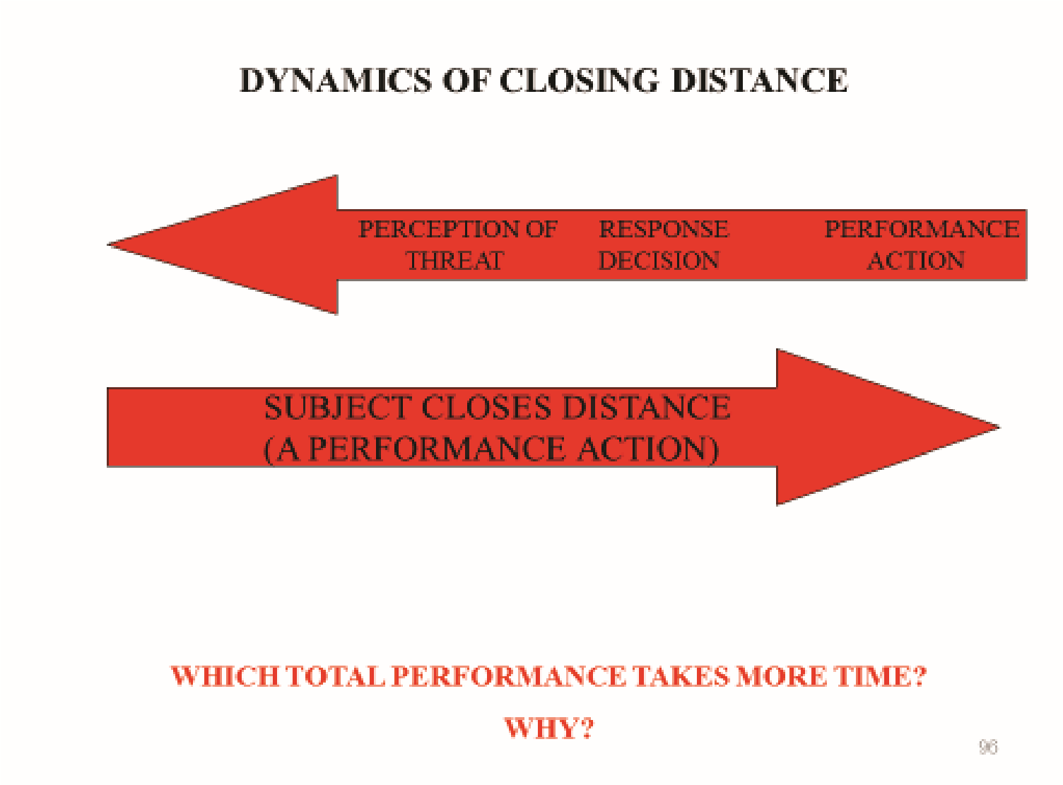*Definition of Serious Bodily Injury: Bodily injury which involves substantial risk of death, protracted and obvious disfigurement, or protracted loss or impairment of the function of a bodily member, organ or mental faculty.*

Deadly force is always the last resort used in the direst of circumstances. The authority to use deadly force is a tremendous responsibility given to peace officers by the people who expect th

to exercise that authority judiciously. In the law enforcement/community partnership, peace officers are expected to be self-disciplined and accountable.

An officer may use deadly force to protect oneself or others when the officer has the objective and reasonable belief that his/her life, or the life of another, is in imminent danger of death or serious physical injury based upon the totality of the facts known to the officer at the time.

Considerations When Deciding to Use Deadly Force

The decision of whether or not to use deadly force may be influenced by the officer’s:

* training and experience
* judgment
* mental alertness
* emotional maturity
* existing facts and circumstances
* understanding of the law as it relates to o agency policies concerning the use and amount of force that is objectively reasonable to achieve the law enforcement mission.

Although the law and courts have established a baseline for the use of deadly force, the conditions under which deadly force may be used are strictly controlled by agency policy. *Officers must conform to agency policy and federal and state law.*

Some issues regarding the use of deadly force addressed by agency policies include, but are not limited to:

* defense of self and others against great bodily harm or death  use of warning shots  shooting at:

o nonviolent fleeing felons o moving vehicles

* shooting from a moving vehicle
* intentional strikes to the head or neck with an impact weapon

In some instances, peace officers may have time to evaluate and assess all aspects of a situation. In most situations, split-second decisions must be made.

As part of the mental process for preparing to use deadly force, peace officers should consider several important factors *before* a situation requiring the use of deadly force arises. The following list(s) suggests, but is not limited to, a few of the circumstances that should be considered.

Threats to Life:

* Does the subject(s) present a credible threat to the officer or others?

Imminent Threat: [Thoroughly cover and demonstrate ‘Closing Distance.’]

*Closing Distance means an overt act(ion) that moves a subject from a threat to attacking and creates an opportunity to complete an attack.*

* Does the subject(s) present an imminent threat to life?
* Is the subject threatening the officer or others with a weapon?
* What is the subject’s access to weapons or potential weapons?
* What is the proximity of the subject(s) to the officer?

Type of Crime/Subjects

* Is the nature of the crime violent or non-violent?
* Is there a large number of subjects to be confronted?

Type of Weapon:

* Can it cause serious bodily injury or death?

Subject(s) Capabilities:

* Does the subject demonstrate superior physical skill over the officer?

Officer’s Capabilities:

* What sort of weapon or other capabilities are available to the officer?

Environment:

* Is there a crowd of innocent people behind the subject?

*NOTE: Officers must always take into account the totality of circumstances when selecting a force option for a given situation. It is not the intent of the above list to imply that any one circumstance alone may or may not justify the use of deadly force.

___________________________________________________________________________ **Justifiable Homicide by Public Officer**

Homicide is the lawful or unlawful killing of a human being by another human being. Under certain circumstances homicide by a public officer can be justifiable and legal.

*Section 30-2-6, NMSA 1978* states: “Homicide is justifiable when committed by public officers and those acting by their command in their aid and assistance, either:

* in obedience to any judgement of a competent court,

* when necessarily committed in overcoming actual resistance to the execution of some legal process, or in the discharge of any other legal duty,

* when necessarily committed in retaking felons who have been rescued or have escaped, or when necessarily committed in arresting felons fleeing from justice, or

* when necessarily committed in order to prevent the escape of a felon from any place of lawful custody or confinement.”

_____________________________________________________________________________

# Unjustifiable Homicide by Public Officer

The following examples illustrates circumstances under which homicide by a public officer may not be justified (based on mitigating factors):

**Homicide by a public officer Explanation:**

**may NOT be justified when...**

Pursuing nonviolent felons. In the case of nonviolent

offenses, such as forgery or

grand theft, the consideration

for human life and the safety of

bystanders would preclude

shooting the subject.

If it is not a violent felony, then

Arresting or pursuing a felon the use of deadly force against

who does not present a threat to the fleeing subject would be improper.

life. A violent felony is one which threatens death or

serious bodily harm.

When arresting or pursuing a When an arrest is for a

misdemeanant who does not misdemeanor, use of deadly

pose imminent danger of death force is not justified. It is the principle of law

or serious bodily injury to that is better to allow the misdemeanant to

people. escape than to apply deadly force against the

individual.

______________________________________________________________________________

# Communication

Effective communication may enable a peace officer to gain cooperation and voluntary compliance in stressful situations (e.g., confronting a hostile subject).

The vast majority of law enforcement responsibilities involve effective communication. Communication involves both command presence and words resulting in improved safety. The following examples demonstrate some benefits of effective communication:

For Safety, effective communication:

* Provides skills that reduce the likelihood of physical confrontation.
* May result in a reduction of injuries.

For Professionalism, effective communication:

* Renders more effective public service and improves community relations.
* Decreases public complaints and internal affairs/professional standards investigations.
* Decreases civil liability.
* Lessens personal and professional stress.

Law enforcement is a highly visible profession. When peace officers communicate, they represent, for better or worse:

* Themselves and their agency
* Executive staff (chief or sheriff)
* Government (city, county, state, federal)
* Public interest
* Authority (laws, the Constitution, the Bill of Rights, etc.)  Law enforcement profession as a whole.

______________________________________________________________________________

# Self-Control, Fear and Anger Management in the Use of Force

Reverence for the law is the basis for the use of reasonable force by peace officers. The rule of law is what distinguishes democracy from authoritarian control. The use of reasonable force is guided and restricted by ethics, law and agency policy. Officers study law and policy so they act lawfully and ethically and confidentially withstand the test of public scrutiny.

When peace officers use force, there are several factors that can influence their actions and the outcome of the event. These include the officer’s:

* attitude or prejudices toward any involved party (e.g., self, partner, bystander, subject, etc.)
* insensitivity or arrogance, creating a negative emotional response.
* sincere and courteous behavior, reducing problems and danger associated with an arrest.
* life experience, past performance, training, etc.

______________________________________________________

Self-control is one of a peace officer’s greatest assets in dealing with a person or a situation.

Self-control:

* is a result of the development of confidence in one’s skills  also comes through training, practice, and experience.
* improves decision making/reaction time.

**Self-control** is maintaining composure to make sound judgments and decisions.

Some subjects can be controlled by the *peace officer’s command presence.*

* Professional demeanor can have a positive influence on calming a subject, making it easier to take the subject safely into custody.
* Nonprofessional demeanor can easily lead to increased conflict, encouraging dangerous behavior by the subject and resulting in poor behavior on the part of the officer.

The use of force in dangerous situations may bring on emotional responses as well as physiological responses that officers must be prepared to recognize and manage.

Two major emotional factors that officers need to focus on to maintain self-control are:

* fear, an emotional response to a perceived threat
* anger, a feeling of displeasure from perceived opposition.

It is important to understand fear and anger since both can affect officers’ reactions during a dangerous situation.

* Uncontrolled fear and anger tend to decrease the officers’ ability to make sound judgments and decisions.
* Uncontrolled fear and anger tend to increase hesitation, verbal abuse, and unreasonable force.

**Fear** is a normal emotional response to a perceived threat (real or unreal). Fear is normal and does not become a problem until it interferes with the ability to perform effectively.

Everyone has experienced the sensation of fear. It is unpleasant but normal, natural, and often necessary.

A person’s fear changes with time and experience. Fear may alter alertness during stressful situations. Courage or bravery are not the lack of fear, but in fact, the control of fear.

When a person experiences fear, the body reacts, often by an increase in adrenaline, heart rate, and breathing. In addition, some common body and mind responses to fear may include:

* blood clotting enzymes flow into the system to minimize damage from wounds.
* vision and hearing become more acute and focused (e.g., tunnel vision and tunnel hearing)  increased muscle tension and perspiration  raised pain thresholds.
* time distortion
* color distortion
* impaired fine motor skills

There are two types of fear: reasonable and unreasonable.

Reasonable Fear:

9 A mechanism that is necessary for officer safety based on perceived circumstances. 9 A controlled and legitimate fear

Reasonable fear may result when an officer experiences increased tension in response to a potential threat.

The officer may experience **reasonable fear** as a result of:

* a sudden or erratic movement by a subject
* the sight of a weapon in a subject’s possession
* the knowledge that a person is in danger of bodily harm.
* a sudden sound produced outside of the officer’s field of vision.  unexpected response to the officer’s action

Unreasonable Fear:

9 Generated in the officer’s mind with no direct correlation to facts and situations.

Unreasonable fear includes overreactions to true potential threats as well as reactions to unreal threats based on prejudice or poor application of past experience.

The officer may experience **unreasonable fear** as a result of:

* an emotional response to a traumatic event
* generalization of past trauma (such as being bitten by a dog as a child or suffering a painful gunshot wound)
* personal prejudice against people of a particular race, religion, ethnic group, etc.  overall anxiety as a result of uncertainty about one’s own skills and expertise.

Unreasonable fear can be responsible for inappropriate responses such as a failure to respond or responding inappropriately (using unreasonable force).

There are several factors that can lead to unreasonable fear, some physical and some social. The following examples highlight some types of fear.

Physical Sources of Unreasonable Fear:

* Personal physical harm
* Phobias …(e.g., claustrophobia)
* Psychological (e.g., paranoia)

Social Sources of Unreasonable Fear:

* Racial, cultural, or religious-based
* Responsibility for making critical decisions.
* Peer disapproval

Effectively Managing Fear

It is normal for peace officers to experience fear whenever they encounter a potentially dangerous situation.

Discussing fears with others is one step toward managing fear. In addition, going through the mental rehearsal before an incident takes place (“what ifs”) as well as after-action assessments

(“what could I have done differently”) will better prepare the officer in effectively dealing with fear.

Other methods for managing fear include focusing on:

* what must be done and not solely on the danger itself?
* evaluating the situation and determining what must be done to achieve the goal.  the survival phase in order to control the feeling of vulnerability.

**Anger** is a feeling of displeasure from perceived injury, mistreatment, or opposition, to oneself or to another person. When anger is inappropriate or out of control (i.e., rage), it becomes a liability.

Peace officers often act as if they should not have angry reactions to things they see or experience during the performance of their duties. Denying or suppressing anger for long periods may create emotional and physical problems.

To a certain extent, anger allows officers to be assertive. It even plays a small role in command presence.

Peace officers have reported that anger appropriately channeled has enabled them to keep fighting, or at least keep trying, during a crisis situation.

The emotional response of anger can either aid or hinder an officers’ performance.

It is important for peace officers to acknowledge and recognize that anger is a normal reaction. There are two types of situations that can provoke anger, as explained below:

Universal Anger-Provoking Situations:

* Being attacked
* Being shot at

Personal Anger-Provoking Situations:

* Individual sensitivities that may prompt a reaction (e.g., history, personality, etc.)  Emotional bruises and other sources of personal vulnerability

Few people can exercise effective emotional control when they are extremely angry. To avoid getting to this point, peace officers need to prepare themselves for dealing with anger. Some of these methods are listed below:

**Managing anger by...** De-personalizing what people say or do.

**The peace officer needs to...** Recognize that the subject is

reacting to the uniform and not

to the person in the uniform.

|  |  |
| --- | --- |
| Identifying anger inducing scenarios. | Visualize anger inducing situations (e.g., a child taking drugs, subject beating up partner, etc.). |
| Developing problem-solving solutions. | Practice mental rehearsals of different scenarios, do some role-playing, seek advice from more experienced officers, etc. |
| Recognizing the onset. | Control breathing and if appropriate take a step back from the situation. |

# Consequences of Unreasonable Force

Peace officers must recognize the consequences of using unreasonable force, and their legal and ethical responsibilities to intervene if the force being used by another peace officer is inappropriate or unlawful.

Peace officers who make or attempt to make an arrest need not retreat or desist from their efforts because of resistance or threatened resistance from the person being arrested. They are not considered the aggressor, nor do they lose the right of self-defense when they use force to:

* effect an arrest
* prevent escape
* overcome resistance

Justification for the use of force is limited to what is known or perceived by the officer *at the time*. Facts discovered after the event, no matter how compelling, cannot be considered in determining whether the force was justified or not.

The objective for the use of force by peace officers in any situation is to gain or maintain **control of an individual and the situation.** As conditions change, officers must constantly reevaluate force options.

Peace officers are required to:

* use force only when authorized to do so (e.g., to overcome resistance to a lawful process)
* use the type of force which is reasonable under the circumstances
* use reasonable force to overcome resistance and to gain or maintain control
* use the amount and type of force which is permitted by agency policy



**Unreasonable force** occurs when the type, degree, and duration of force employed was not necessary or appropriate.

Malicious assaults and batteries committed by peace officers constitute unlawful conduct. When the force used is unreasonable, the officer can face criminal and civil liability, and agency disciplinary action.

The following chart highlights a number of these consequences:

|  |  |
| --- | --- |
| **Consequence** | **Officers may...** |
| Criminal action | Face criminal charges for unreasonable use of authority or force. |
| Civil lawsuits | Face compensatory and punitive damages. |
| Civil rights violation | Be held accountable for civil rights violations. |
| Administrative or agency action | Be subject to disciplinary actions including dismissal. |
| Moral impact | Suffer the consequences of guilt and embarrassment. |

______________________________________________________________________________

There are two sections of the United States Code that address an officer’s unlawful action:

**Description**  ***U.S. Code Section***

Peace officers are prohibited from depriving *Title 18, Section 242* (*Criminal*)

citizens of their rights under the color of the law.

If death results, officers may be punished by life imprisonment.

Peace officers are prohibited *Title 42, Section 1983*  *(Civil)*

from depriving citizens of their

rights under the color of

authority.

**\***Qualified Immunity under 42 U.S.C 1983:

Shields government officials (law enforcement officers) from liability provided their actions were:

* Reasonable under the circumstances
* Did not violate “clearly established law.”

Civil Liability at the State level

 New Mexico Tort Claims Act – 41-4-12

# Vicarious Liability

The unreasonable use of force by an officer can discredit and result in loss of public support to an officer’s agency.

Vicarious liability holds an agency responsible for the conduct of its officers while acting within the scope of their authority. The agency can be:

* liable under Federal civil rights laws
* sued for negligent or inadequate training or failure to supervise adequately.

__________________________________________________________________________

# Duty to Intervene/Failure to Intervene

The community expects that its peace officers will use reasonable force, and peace officers will intervene if reasonable force is exceeded. For the community and the officer’s protection, the officer must know the laws pertaining to intervention.

This intervention may take the form of one or more of the following actions:

* strongly caution the other officer
* physically restrain the other officer
* immediately report the incident

**Intervention** is the act of attempting to prevent or attempting to stop the inappropriate or unlawful behavior of another.

The United States Constitution protects individuals from unlawful actions of peace officers. NOTE: The officer who fails to intervene, for whatever reason, is also held accountable by the United States Code.

An officer may face both criminal or civil liability and disciplinary action if they fail to intervene and prevent other officers from violating anyone’s constitutional rights if they had reason to know and an opportunity to act. *US v Koon*, 34F. 3d 1416at 1447 (9th Circuit,1994); *Cunningham v Gates*,

229F.3d 1271 at 1289-1290 (9th Cir., 2000), *Samuels v. Cunningham*, 2003 U.S. District LEXIS 14479 (Dist. Del), *Jones v. City of Hartford*, 2003 U.S. District LEXIS 17340 (Dist CT)

Samuels v. Cunningham et al: ‘Officers who have an opportunity to intervene in an excessive use of force must do so, or risk personal liability for a civil rights violation based upon their failure to intervene provided they have an opportunity to do so.’

Jones v. Hartford: ‘Police officers have an affirmative duty to intercede on behalf of a citizen whose constitutional rights are being violated in their presence by other officers.’

Intervention is necessary because:

x it is required by law. x it is morally and ethically correct. x personal integrity demands it. x it enhances officer safety. x it preserves professionalism and supports the law enforcement mission.

x it strengthens public confidence in the law enforcement profession and the individual agency involved.

x it reduces personal and agency liability because it results in fewer:

* physical injuries arising from unreasonable force.
* disciplinary actions and personal complaints o criminal complaints filed against officers. o civil liability suits, including fewer punitive financial judgments against individual officers.

______________________________________________________________________________

# Documenting Use of Force

When a force option has been employed, peace officers’ reports must include the critical information to ensure that the chronology, specifics of the events, and the people involved are properly documented.

A peace officer’s ability to clearly document the facts and activities of a use of force incident not only reflects on the officer’s own professionalism, but also on the ability of the justice system to prosecute the criminal case or limit civil liability. Every use of force incident is different and may require different information.

The Objective Reasonableness Standard

The U.S. Supreme Court has determined that the objective reasonableness for the use of force must be *fact specific*.

**The reasonableness of an officer’s Use of Force in the line of duty must be...**

* judged from the *perspective of a reasonable officer.*

* examined through the eyes of a reasonable officer on the scene *at the time the force was applied*. Not 20/20 hindsight

* based on the facts and circumstances confronting the officer *without regard to the officer’s underlying intent or motivation*.

* based on the knowledge that the officer *acted properly under the established law at the time*.

In order for the officer’s actions to be properly evaluated, the courts must rely on the documentation of all relevant factors.

**It is imperative that *each* report be thorough and comprehensive, documenting all aspects of the use of force based on the officer’s recollection.**

There are six areas that should be thoroughly addressed in your documentation:

* The three-prong test in *Graham v. Connor*

* + the severity of the crime at issue. *For example, misdemeanor v. felony; violent crime*

*v. property crime; crime involving a weapon v. a weaponless crime.*

* + whether the suspect poses an immediate threat to the safety of the officer or others.

*For example, armed v. unarmed, demonstrated intent by an overt act(ion).* o whether the suspect is actively resisting arrest or attempting to evade arrest by flight. *For example, walking/running away, pushing, shoving or similar overt act(ion)s.*

The balancing test in *Graham v. Connor*

* The nature and quality of the intrusion on the individual’s Fourth Amendment interests against the countervailing governmental interests at stake. *For example, what was the suspect doing at the time the officer applied force? Was that level of force that was used by*

*the officer objectively reasonable when compared to the level of threat posed by the suspect?*

* All pre-assault indicators. For example, clenching of the fists, assuming a fighting stance, target glances at an officer’s weapon, distracted gaze and hesitation between answering questions.

* Totality of the circumstances: Examples which may include any or all of the following:

* + Duration of the action? o Did force applied result in injury? o Previous violent history of the subject (known to the officer at the time of the incident?)
  + Was subject using or under the influence of alcohol and/or drugs? o Were there innocent bystanders present who could have been injured if force was not used and/or were in jeopardy?
  + Availability of other weapons? o Ability or inability of the officer to disengage? o Injury to the officer?
  + Exhaustion to the officer? o Daylight/Night-time?
  + Environment (ground cover, treacherous step terrain, water, residential, commercial, urban, or remote area)
  + Body size disparity o High crime area? o Multiple suspects? o Mentally unstable subject?
  + Subject ability or inability to comply?

Also, refer to the below descriptors for additional information which may be applicable to the totality of circumstances:

It sometimes takes years before a case works its way through the court system. As time increases between the incident when force was used and any legal or civil action:

* an officer’s memory may fade.
* evidence may be destroyed.
* a witness may be unavailable or cannot be located.

To ensure that all the relevant information is included in their reports, officers need to be aware of the degree of detail required when documenting the use of force.

**Precursory acts** are those events that led up to the encounter with the subject, including how the officer arrived at the scene as well as what observations helped the officer assess the situation.

Giving detailed information of the precursory acts provides the background information necessary to justify the use of force. Possible information includes, but is not limited to:

* establishing that the officer was acting in an official capacity.
* the wearing of an approved uniform that clearly identifies the officer as a peace officer.
* the mode of travel and whether or not the vehicle was clearly identifiable as a law enforcement vehicle.
* identification as a peace officer
* the reason for the officer’s presence

Orders, Commands, Requests and Reponses

Officers should describe the specific orders, commands, or requests that they gave to the subject. *Both* the officer’s and the subject’s responses and reactions to those commands should be documented, including direct quotes if possible.

Factors and Characteristics

Officers need to describe the factors between the subject and themselves that justify the use of force, including but not limited to:

* number of officers/subjects
* height and weight of each subject
* gender and age of each subject
* strength and fighting skills of each subject.
* physical condition of each subject
* clothing (i.e., uniform with equipment vs. casual attire)
* stance of each subject (describe)

In addition to the subject’s physical attributes, it is necessary to document the specific characteristics regarding the identification of a subject. Some characteristics include, but are not limited to:

* prior contact
* obvious prison or gang tattoos
* specific gang attire
* access to potential weapons such as knives, boots, rings, or guns

Environment

Officers should observe and record details regarding the environment where the confrontation took place. This information includes, but is not limited to:

* physical environment where the contact took place (e.g., high crime area, etc.) 9 subject’s potential to gain assistance or aid from friends or associates.

Subject Resistance and Officer Perception of Threat

The resistance must be precisely defined. At each stage of the account, the officer must clearly articulate the subject’s resistance and the officer’s response to the resistance in his/her effort to gain compliance.

When describing the appropriate response, it is imperative officers document their perception of the threat. Without fear, or without feeling threatened, the officer has no legal right to use higher levels of force. If the officer doesn’t believe his/her safety, or the safety of another, is threatened, then only passive techniques may be used. For example, some officers, reluctant to admit during testimony they were afraid, have foolishly stated they did not fear a knife-wielding assailant. A plaintiff’s attorney or prosecutor could then logically ask, “If you did not fear death or serious bodily injury to yourself or another, then why did you use deadly force?” *For every action taken by the resistor, the officer must not only state the officer’s physical response, but also the officer’s mental and emotional response.*

Describing the Type of Force Used

Officers need to be very clear regarding the type of force applied in given situations. This includes, but is not limited to:

* identifying techniques by their proper names and providing a written description 9 the effect or non-effect of the force technique used upon the subject.
* the rationale for adjusting and transitioning the level of force. 9 communication before, during or after the use of force

Post-Custody Actions

After the subject has been taken into custody, peace officers should describe other actions such as, but not limited to:

* safe and effective adjustment of handcuffs
* double locking the handcuffs (reduces the possibility of inflicting injury from handcuffs over-tightening)
* obtaining first-aid or medical treatment for the subject and/or themselves when reasonably safe to do so.
* damage to their clothing (i.e., uniforms) and equipment
* collection of evidence (what, where, and by whom)

Witness Statements

Statements made immediately after the confrontation are often the most accurate since there is little time to become confused or let outside influences confuse the facts. Whenever possible, witnesses should be located and interviewed at the scene of the confrontation.

Use of a Body Camera (Lapel) to video the statements of witnesses and subjects may be beneficial to the reporting officer.

NOTE: It is important to collect all statements including those persons who claim they did not see any part of the incident.

Below is a quick checklist that may aid officers in documenting their Use of Force report.

**Use of Force Totality of the Circumstances Documentation Checklist:**

* The Pre-Force Information: Day, date and time, location of the incident, officers involved, witnesses, your initial observations “What drew your attention.”
* Approach Considerations: Why did you initiate contact, justification, safety of approach, reasonable suspicion, probable cause, other.
* Tactical Deployment: How did you approach and why, environmental description, control of distance, positioning, team tactics and, call for assistance.
* Tactical Evaluation: What were your perceptions, threat assessment, gut feelings, fear?

Individual’s ability to understand your requests, mental status as observed by the officer.

* Level of Resistance: What did the subject do, unresponsive, non-responsive, ignoring you, dead weight tactics, resistance tension, tightening up, attempting to get away, pushing off, actual physical assault. Verbal defiance and wording responses.
* Early Warning Signs: Consciously ignoring you, excessive emotional attention, and exaggerated movements, ceasing all movements, target glancing, looking around, Boxer’s stance, hand set, shoulder shift, thousand yard stare, known violent background.
* Weapon Threat Assessment: What weapons were brought to the scene? What weapons were accessible to the subject? What were the officer / subject differences: size, agility, strength, age, gender, numbers involved, and skill level?
* Special Circumstances: your perception to the threat, sudden assault, your physical position, subjects’ ability to escalate force rapidly, your knowledge of the individual, your injury or exhaustion, number of friends or other resistors around.
* During Force Objectives: Type of force technique utilized by officer, type of resistance applied by the subject, stabilization, minimizing injury or amount of injury, application of restraints and what type, monitoring, debriefing, searching, escorting, seclusion, medical observation, hospitalization.
* Post Force Level of Resistance: Continued level of anger, after restrained still kicking, head butting, bumping, and pulling away, spitting, threatening verbiages.
* Officer Relaxation: Post force officer’s ability to regain composure and relax prior to the assumptions of duties and initiating the report. (Graham v. Connor, 490 U.S. 386, 395–96 (1989).

## Summary

Broadly speaking, the use of force by law enforcement officers may become necessary at any time and is permitted under specific circumstances, such as in including self-defense or in defense of another individual or group.

There is no single, universally agreed-upon definition of use of force. The International Association of Chiefs of Police has described use of force as the "amount of effort required by police to compel compliance by an unwilling subject." International Association of the Chiefs of Police, *Police Use of Force in America, 2001* (pdf, 88 pages), Alexandria, Virginia, 2001.

Officers receive guidance from their individual agencies and constitutional law provides legal parameters under which police use of force response will be reviewed and evaluated, but no universal set of rules governs specifically when officers should use force and how much.

**Context counts.** No two situations are the same, nor are any two officers. In a potentially threatening situation, an officer will quickly tailor a response and apply force, if necessary. Situational awareness is essential, and officers are trained to judge when a crisis requires the use of force to regain control of a situation. In most cases, time becomes a key variable in determining when an officer chooses to use force.

It is imperative that officers understand the law(s) under which they operate. It is equally critical that officers stay vigilant and aware. While it is our objective to resolve all incidents safely and peacefully, subject resistance can take many forms and in those specific situations the law enforcement purpose is to respond to that resistance using a level of force that is appropriate and objectively reasonable, always considering the totality of the circumstances.