2025 Tourniquet & Trauma Kit NMLEA Accreditation Number: NM250005

_______________________________________________________________________________________________



Tourniquet and Trauma Kit: NM250008

**New Mexico Law Enforcement Academy Annual In-Service Training Curriculum 2025**

**COURSE TITLE:**

2024-2025 In-Service Tourniquet & Trauma Kit (Stop the Bleed)

**TERMINAL LEARNING OBJECTIVE:**

To refresh prior knowledge, skills and abilities in how to control a life-threatening bleed.

**ENABLING LEARNING OBJECTIVES:**

1. LOCATE AND INDENTIFY A MAJOR BLEED
2. STOP THE BLEED BY DIRECTOR PRESSURE, WOUND PACKING AND TOURNIQUET APPLICATION

***INSTRUCTIONAL METHODS:***

**Discussion, lecture, practical application**

**HANDOUTS: Lesson Plan**

**COURSE DURATION: 30 MINUTES**

**CURRICULUM REFERENCES:** **Bleeding Control – Stop the Bleed Course**

**EQUIPMENT, PERSONNEL, AND SUPPLIES NEEDED: Training equipment**

**TARGET AUDIENCE:** **Certified Police Officers**

**INSTRUCTOR RATIO:** **1:10**

**EVALUATION STRATEGY: Demonstration of necessary skills**

**AUTHOR &ORIGINATION DATE:**

**REVISION / REVIEW DATE(S):**

**1/28/22**

**R**

**EVISED / REVIEWED BY:**

**NMLEAB**

***Course Content:***

A. Introduction

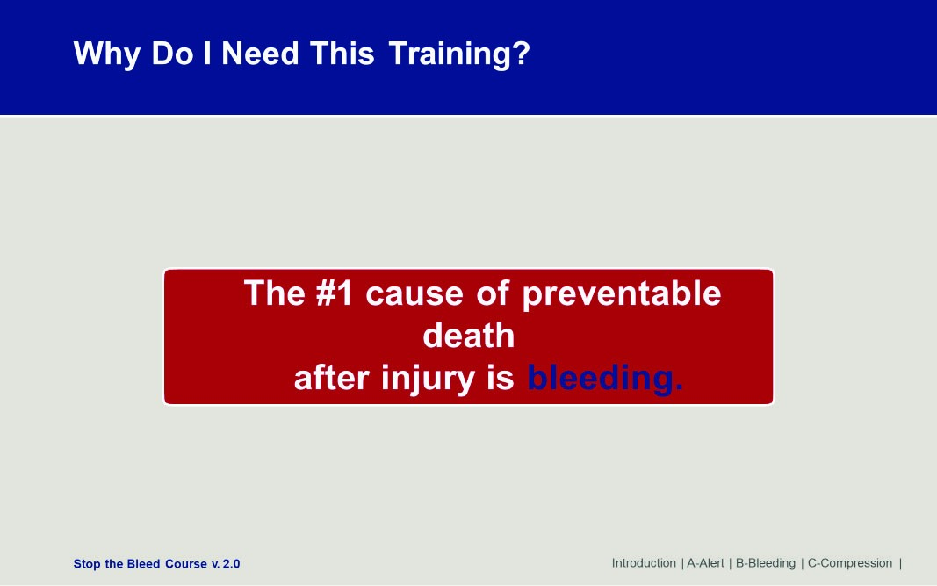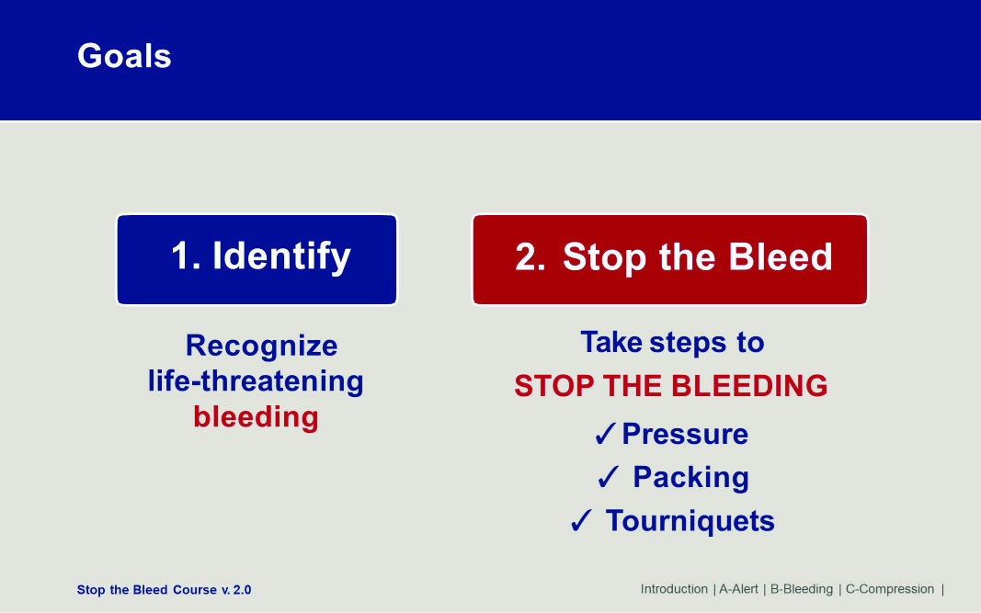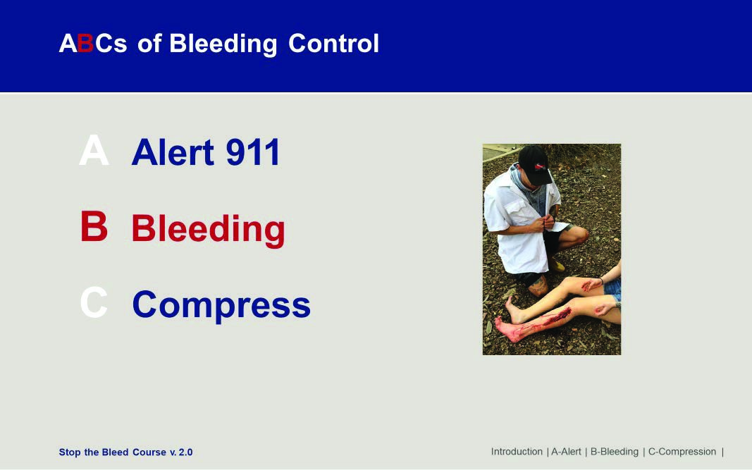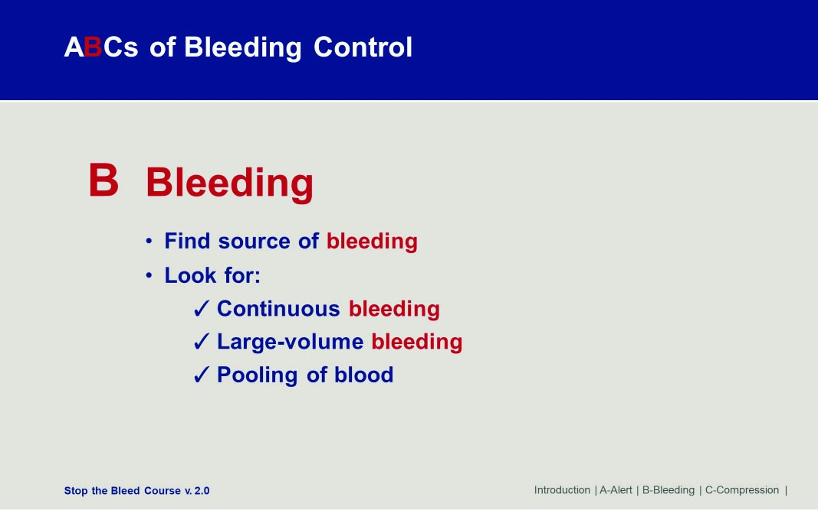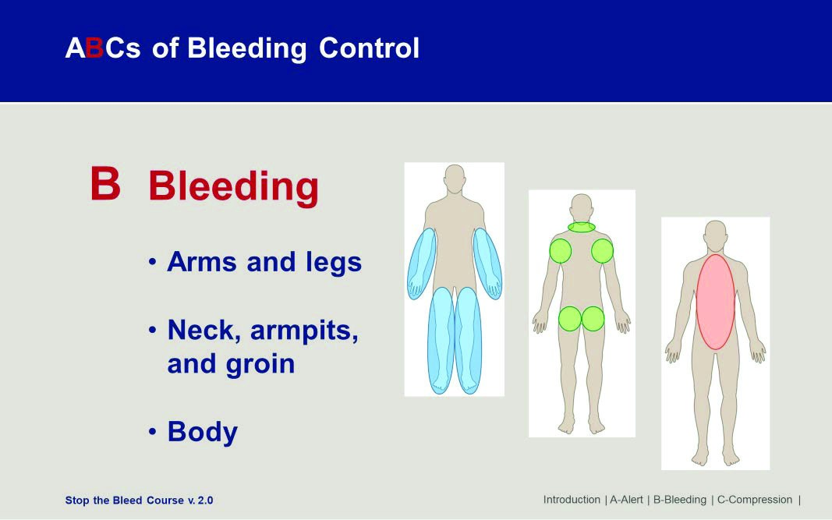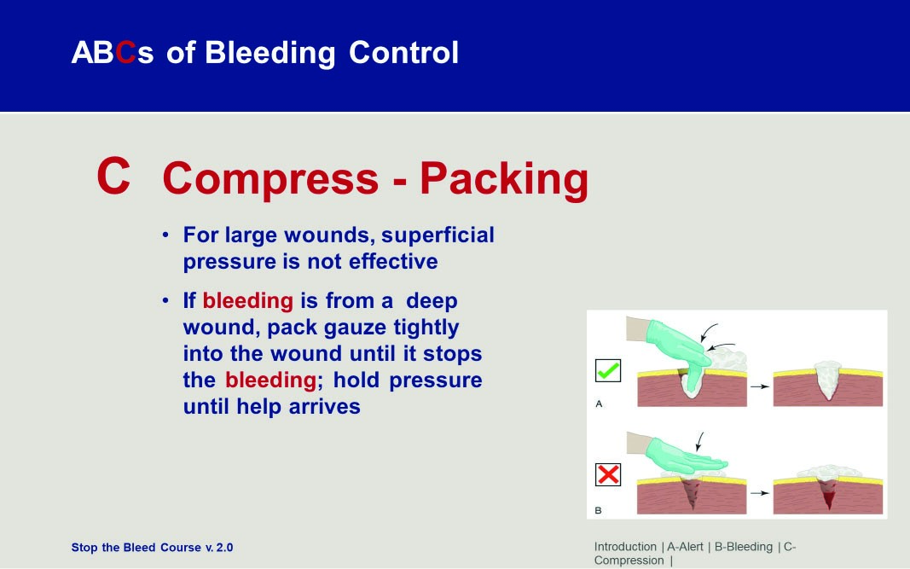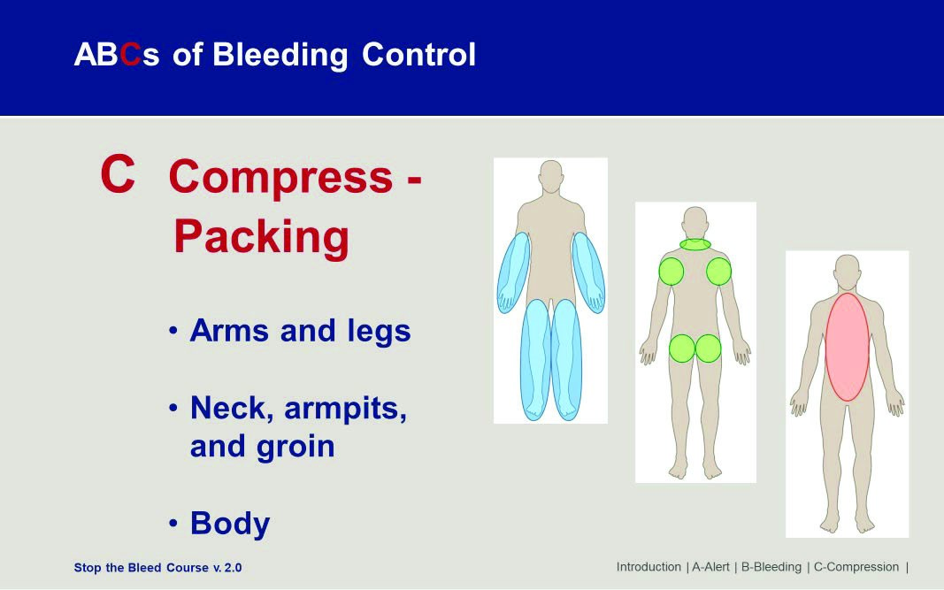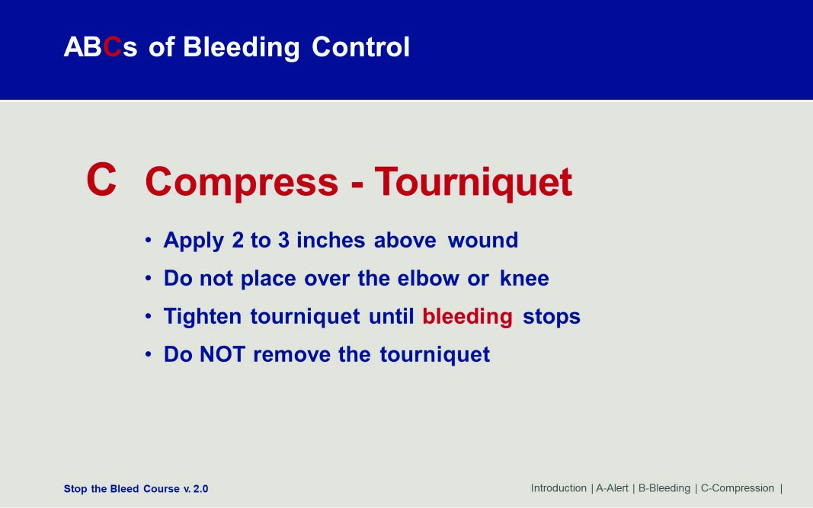

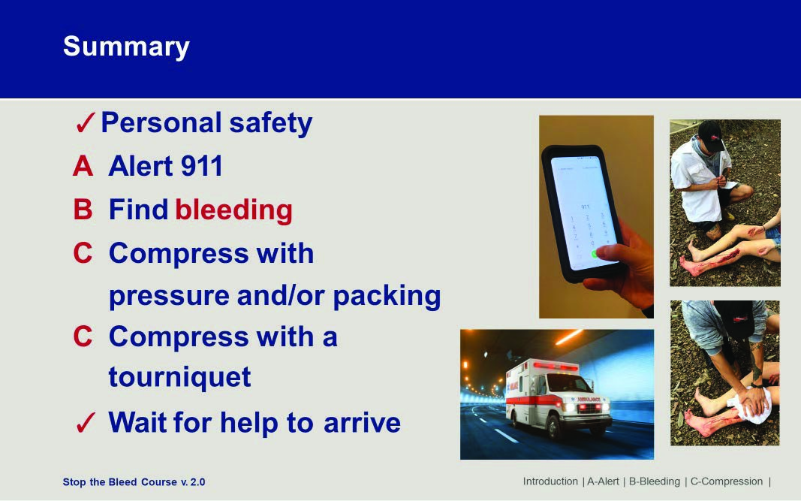

Practical Application:

Students should practice direct pressure and wound packing on a simulated maniquin.

Students should then practice the application of a tourniquet on another’s arm and leg.

Students should then practice a self application on an arm and leg.

Students should then demonstrate the ability to apply a tourniquet to their strong arm in under 2 minutes.

# COURSE AUDIT

PRIMARY INSTRUCTOR:

SECONDARY INSTRUCTOR:

SUPPORT STAFF:

DATE(S)/ TIME(S) OF INSTRUCTION:

LOCATION OF INSTRUCTION:

|  |
| --- |
| RECOMMENDED CURRICULUM CHANGES: Identify inaccurate information, outdated information, new information to be added to update material, etc. (Use additional pages if necessary)                    **COURSE AUDIT** (Continued) |

ADDITIONAL INSTRUCTOR COMMENTS: (If any portion of the course content was not presented, indicate the specific content here)

|  |
| --- |
|  |

Alternative curriculum was taught.

Accreditation number of alternative curriculum:

SIGNATURE DATE

Primary Instructor

Reviewed by Program Coordinator

Reviewed by

Reviewed by Director/Chief or Designee